3 muscles: skeletal, cardiac and smooth muscle tissue

2 protein combinations on muscle cell: integrin-associated complex and Dystrophin-associated glycoprotein complex

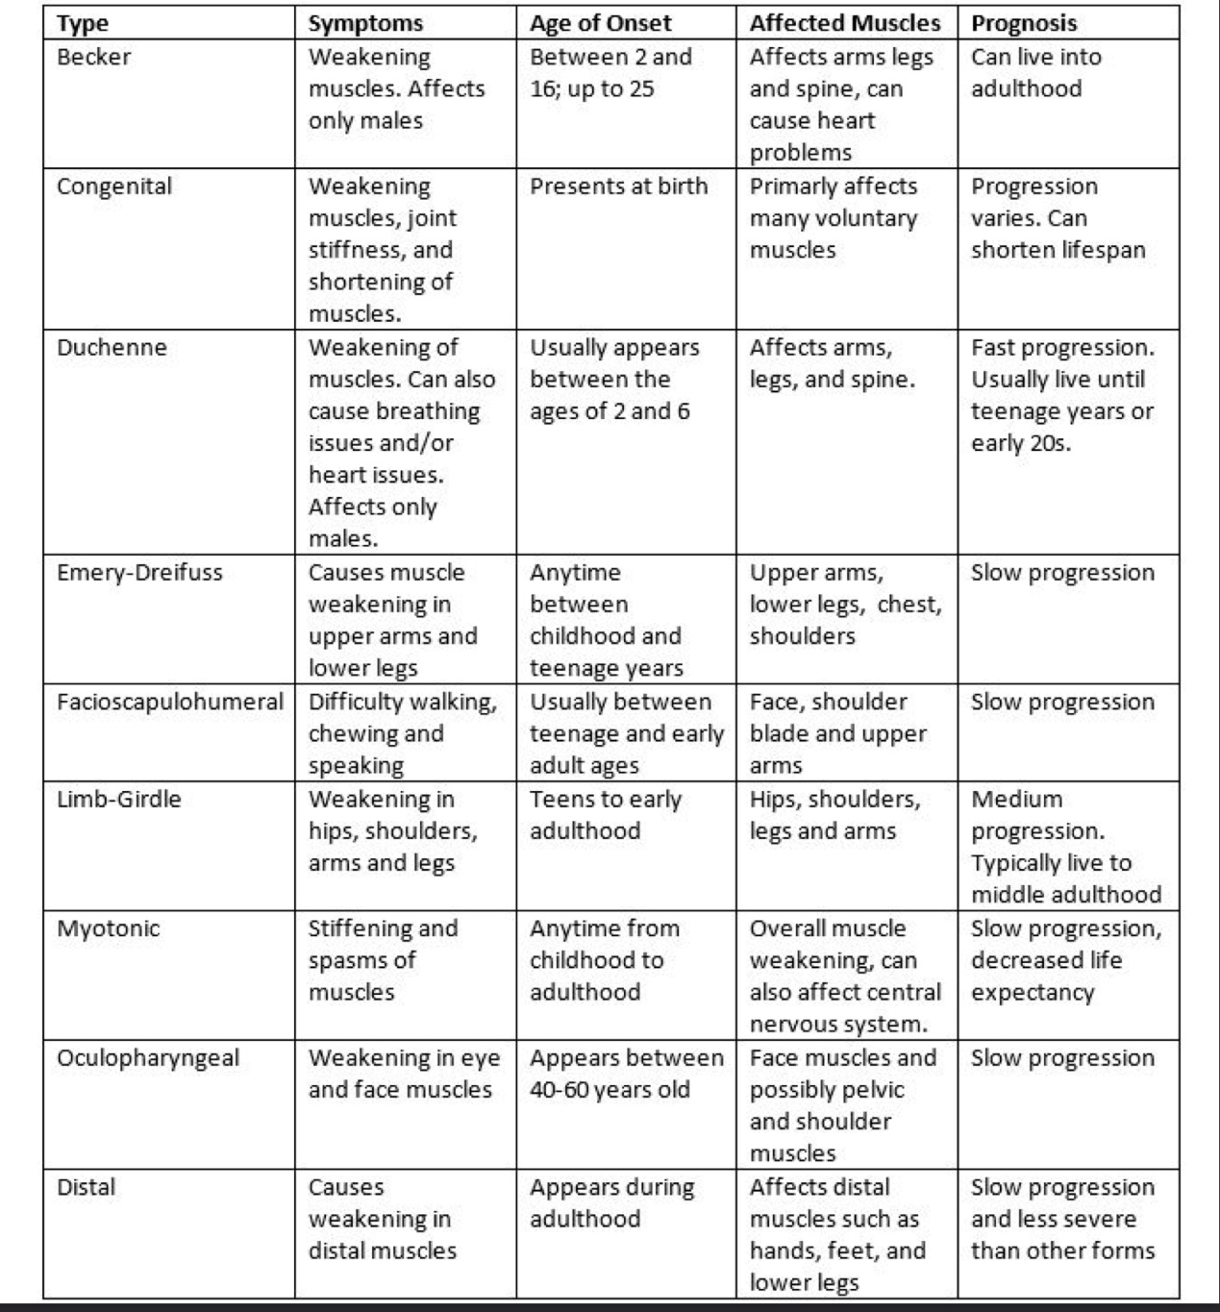

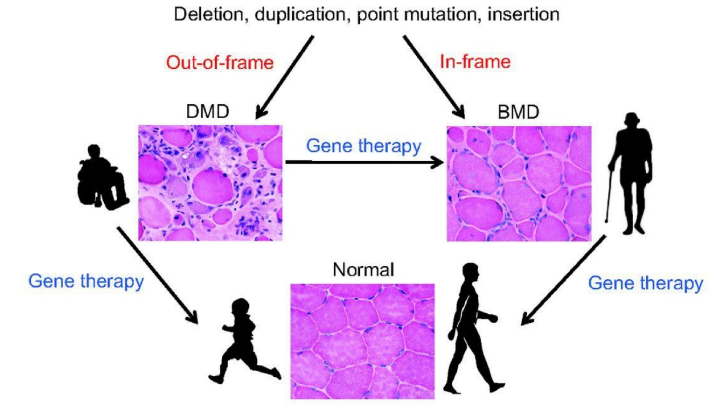

Human/zebrafish: dystrophin

Mouse: dystrophin and utrophin

Why experiment on those creatures: short life span/ similarity to human in genetic level/ easy to observe

Why not use human: painful/too much time/conditions hard to satisfy (fibroblasts and complex media like growth factors)

DMD -> stem cell disease. Why: normal cell has different proteins in two sides while in DMD cells, there are only one protein which will make the cell unable to recognize direction and result in failure in cell division. 